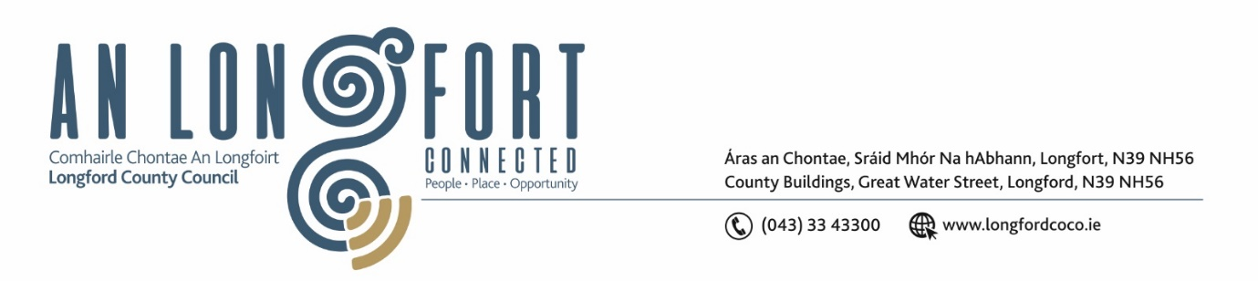

***Please note meeting will be held in the Council Chamber and via Microsoft Teams.***

3 July 2024

**Chuig: Gach Ball don Chomhairle**

A Chomhairleoir,

Iarrtar ort bheith i láthair ag Cruinniú Míosuil Chomhairle Chontae Longfoirt a tionólfar i Seomra na Comhairle, Aras an Chontae, Longford agus via MS Teams are an **Chéadaoin 8Bealtaine 2024 ag 4pm** chun gnó a dhéanamh d’réir an Chláir thíos.

You are requested to attend the Monthly Meeting of Longford County Council to be held in the **Council Chamber and via Microsoft Teams** on **Wednesday 10 July at 4pm** to transact business, as set out on the Agenda hereunder.

Mise le meas,

**__________________**

***Claire McNabola***

***Meetings Administrator***

**C L Á R**

Prayer before meeting.

1. Confirmation of Minutes:
2. Monthly meeting of Longford County Council held on 10 May 2024 – enclosed
3. Annual Meeting of Longford County Council held on 21 June 2024 – enclosed
4. Matters Arising.
5. Declaration of Interest by Members.
6. To note Management Report

**5.** To note adopted Minutes of Corporate Policy Group Meeting held on the

10 April 2024 – enclosed.

1. **Enterprise and Ukrainian Humanitarian Response**
2. **Finance and Information Technology**
3. To note adopted minutes of Governance SPC held on 16 April 2024
4. **Housing, Planning, Regeneration & Capital Projects**
5. Section 183 – 31 Chapel Lane, Longford
6. To Note Planning Applications received
7. **Community, Library and Cultural Services, Corporate and Human Resources**
8. Consideration and adoption of Annual Report 2023 (Enclosed)
9. Consideration of Draft Term of Reference – Place Naming Committee
10. Consideration of Draft Terms of Reference – Protocols & Procedures Committee
11. Consideration of Draft Civic Protocols
12. Appointment of fourth member to the Longford Local Community Development Committee (LCDC)
13. Appointment of third member to Longford Enterprise Development Committee Ltd
14. **Infrastructure, Climate Action and Innovation**
15. To note adopted minutes of Climate Action & Planning SPC held on 31 January 2024
16. To note adopted minutes of Strategic Infrastructure SPC held on 1 February 2024
17. **General**

**Notice of Motions set out here under**

**Councillor Mark Casey**

I call on Longford County Council to seek a meeting with the Bus Eireann School Transport Office, with responsibility for Co. Longford to discuss the number of children omitted from school transport throughout the County

1. **Training Approval**